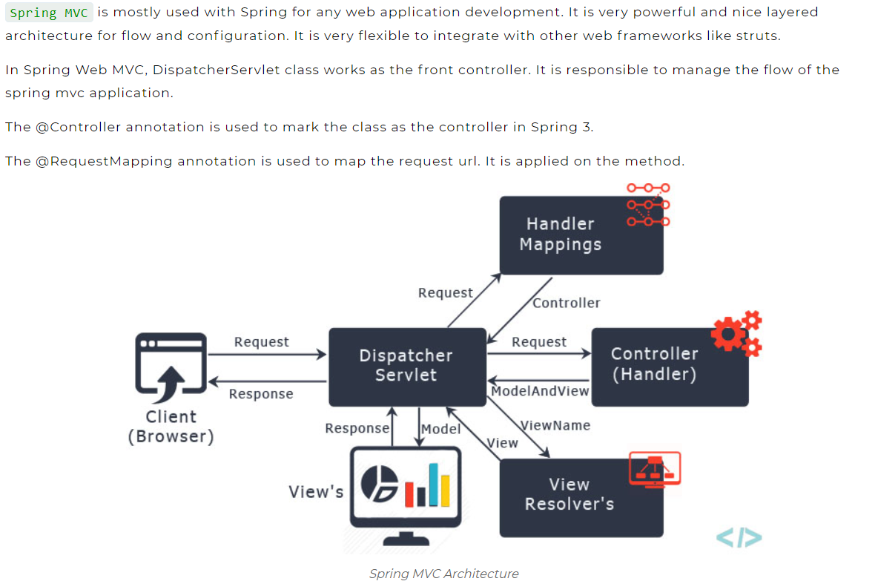

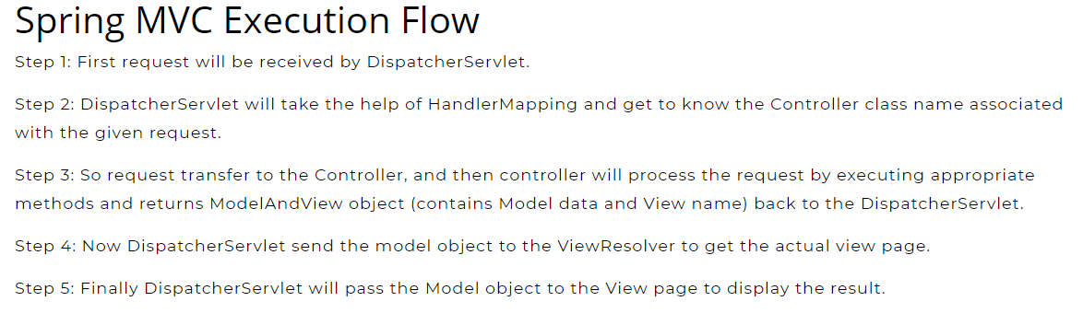

## Understanding Spring MVC Flow Diagram

**1. Request**

The first step in the MVC flow is when a request is received by the Dispatcher Servlet.

**2. Dispatcher Servlet**

Now, the Dispatcher Servlet will with the help of Handler Mapping understand the Controller class name associated with the received request. Once the Dispatcher Servlet knows which Controller will be able to handle the request, it will transfer the request to it.

**3. Controller**

The Controller will process the request based on appropriate methods and will return it to Model Data and View Name.

**4. Model and View**

It will return the processed data to the Dispatcher Servlet.

**5. View Resolver**

Once Model and View receive the data, Dispatcher Servlet will transfer it to the View Resolver to get the actual view page.

**6. View**

Finally, the Dispatcher Servlet will pass the Model object (results) to the view page. This is the final step of the flow where the results will be displayed.

## Advantages of Spring MVC

1. **Different roles:**The Spring MVC has separate roles which can be fulfilled with the help of a specialized object. The roles involved in this are command object, model object, controller, dispatcher servlet, view resolver, validator, and more.
2. **Lightweight:** The container used for the development and deployment of applications uses a lightweight servlet.
3. **Fast development:**The MVC spring framework enables rapid and parallel development. It helps the developer to complete the project on time.
4. **Strong and powerful configuration:** It provides powerful configuration for application and framework classes. These configurations include easy simple referencing like business objects and web controllers.
5. **Business code:** It provides reusable business codes that allow the developer to use existing business objects instead of creating new objects.
6. **Easy testing:** Spring generally uses Java Beans that allows the developer to inject data using easy methods.
7. **Mapping:** It provides flexible mapping that allows the page to redirect easily.
8. **Dependency Injection:**Inversion of Control or dependency injection allows the developer to not create a complete environment for the dependencies.